**_________________** – Critical technique for managing for managing complexity



* Hiding the details when they are not important

**The Three Y’s** – To manage complexity

* **_____________**– A system divided into modules and submodules
* **_____________**– Having well-defined functions and interfaces
* **_____________**– Encouraging uniformity, so modules can be easily reused

**Numbering Systems and Conversion between Systems:**

|  |  |  |  |  |
| --- | --- | --- | --- | --- |
|  | **Decimal** | **Binary** | **Hexadecimal** | **Octal** |
| **Base** |  |  |  |  |
| **Digits** |  |  |  |  |
| **N Digits**  **(i.e. Range)** |  |  |  |  |

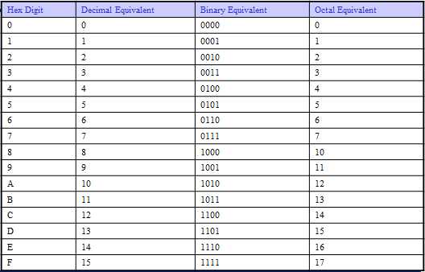

**Base Conversions:**

|  |  |  |  |  |
| --- | --- | --- | --- | --- |
|  | **Convert To:** | | | |
| **Convert From:** | **Binary** | **Octal** | **Hexadecimal** | **Decimal** |
| **Binary** | X | Substitution | Substitution | Summation |
| **Octal** | Substitution | X | Substitution | Summation |
| **Hexadecimal** | Substitution | Substitution | X | Summation |
| **Decimal** | Division | Division | Division | X |

**Base Conversion Practice:**

Dec to Binary: (Called ______________________)

Binary to Hex: (Called ______________________)

Hex to Decimal: (Called ______________________)

**Other Vocabulary:**



Byte – 8-Bits

Nibble – 4-Bits

Word – Variable 8 to 64-Bits



LSB – Least Significant Bit/Byte

MSB – Most Significant Bit/Byte